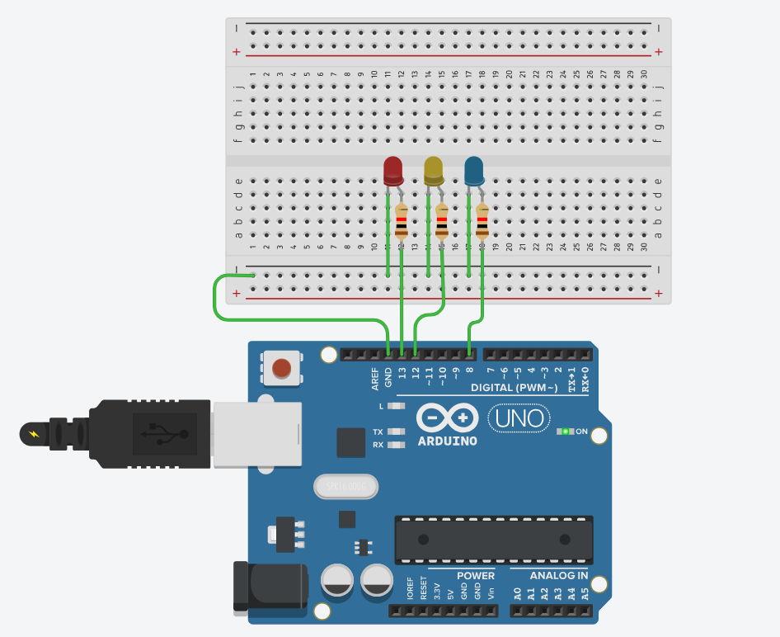
ARDIUNO Practical 1

int led1=13;
int led2=12;
int led3=8;
void setup()
{
pinMode(led1, OUTPUT);
}
void loop()
{
digitalWrite(led1, HIGH);
delay(500);
digitalWrite(led1, LOW);
delay(200);
digitalWrite(led2, HIGH);
delay(500);
digitalWrite(led2, LOW);
delay(200);
digitalWrite(led3, HIGH);
delay(500);
digitalWrite(led3, LOW);
delay(200);
}

